Unit #3 Scratch a programming language

# 1 Introduction

Scratch is a programming language that lets you create your own interactive stories, animations, games, music, and art. It is designed by the Kindergarden Lifelong Learning Group at MIT to introduce some basic programming concepts in a fun and interactive manner.

In Scratch, *sprites* (objects) are manipulated on the *stage* (background/backdrop) using various *scripts* (small program segments). Each sprite has its own set of scripts to control its behaviors and how it interacts with other sprites and events. Programming consists of snapping together individual blocks of preexisting actions to create a script. A program can be as simple as a single block or consist of multiple blocks stacked together that will run as a unit.

DO YOU KNOW?

Scratch is used in more than 150 different countries and available in more than 40 languages. To change languages in the Project Editor, click the globe at the top left corner in the menu bar.



.

Opening Scratch

Users can program in scratch online editor by creating an account and logging in at <https://scratch.mit.edu/> . The website also has a lot of tutorials, helping material and features top projects created by the users.

Alternatively you can download offline editor for scratch which is identical to the one available at the website. To open the downloaded editor on your computer follow these steps:

* Bring up Windows 10 start menu
* Type **scratch** in the search box of Windows 10 Start menu. Then in the program list, it will display the Scratch 2 offline editor. Click to open it

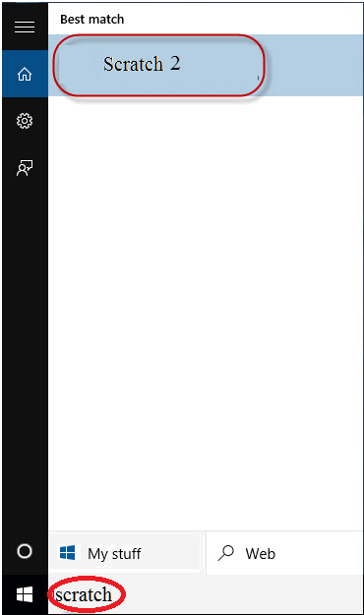

3.1 (a) open scratch offline editor

* Main screen of Scratch 2 offline editor will open.

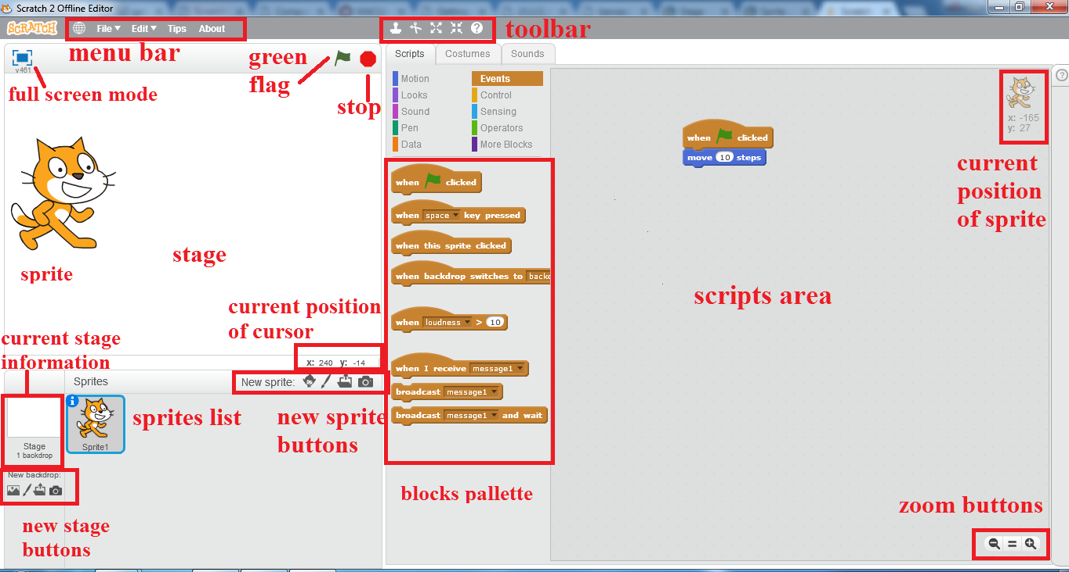

3.2 (b) Scratch main interface

DO YOU KNOW?

The Scratch Wiki is a collaboratively-written wiki available for free that provides information about the Scratch programming language and its website, history, and phenomena surrounding it..

.

* **Scripts**

A script is defined within the Scratch program as one or a set of blocks that begins with a *Hat Block*. Even a single block can qualify as a script. However, scripts are usually referred to as sets of blocks that consist of at least two blocks. A script is a collection or stack of [blocks](https://en.scratch-wiki.info/wiki/Blocks) that all interlock with one another. The blocks and their order are very important, as they determine how [sprites](https://en.scratch-wiki.info/wiki/Sprite) interact with each other and the [backdrop](https://en.scratch-wiki.info/wiki/Backdrops).

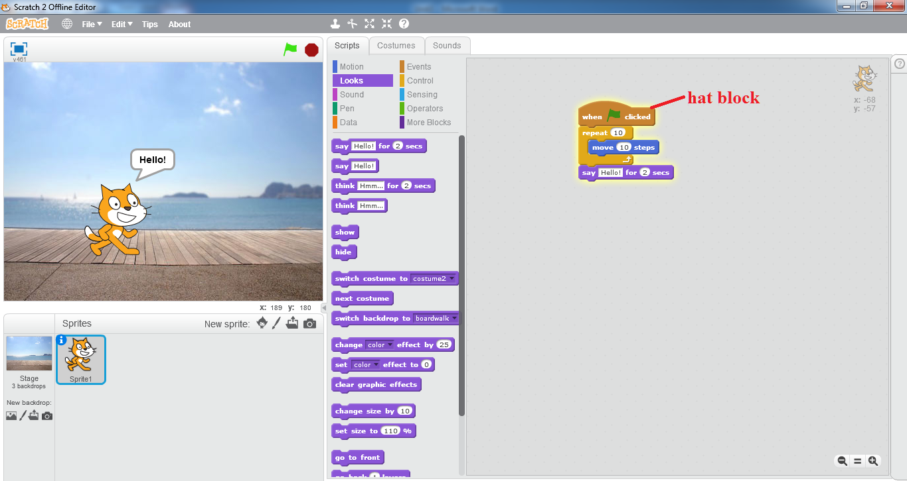

3.1 (c) an example script

* + **Block Shape**

Every block shape is designed so that it can do one or more of the following:

* + - Start a script

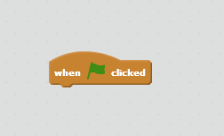

* + - Add to the end of a script

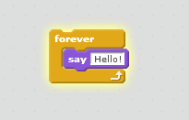

* + - End a script

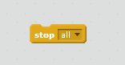

* + - Fit inside other blocks.

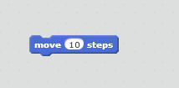

* + - Contain other blocks.

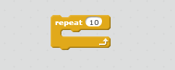

Because of that, blocks can be assembled to create a script like a jigsaw puzzle. This prevents syntax errors.

* + **Using Scripts**

Scripts are easy to work with. Some "rules" are as follows:

* + - To create a script, one simply has to drag blocks out of the [*Block Palette*](https://en.scratch-wiki.info/wiki/Block_Palette) and assemble them.
    - To assemble blocks, they must be dragged on, below, or inside another block. (Except for [Hat Blocks](https://en.scratch-wiki.info/wiki/Hat_Block).)
    - To disassemble blocks, they must be dragged apart.
    - To remove a script, drag it into any of the block palettes, or right-click the hat block and press delete to remove the whole script.
    - To start a single script just click on it.

Scripts can be edited in the scripts tab of every sprite and the [Stage](https://en.scratch-wiki.info/wiki/Stage).

* **Costumes**

A **costume** is one out of possibly many frames or alternate appearances of a [sprite](https://en.scratch-wiki.info/wiki/Sprite). Sprites can change their look to any of its costumes. They can be named, edited, created, and deleted, but every sprite must have at least one costume. One of the most common uses of costumes is to make an animation for a game or other project.

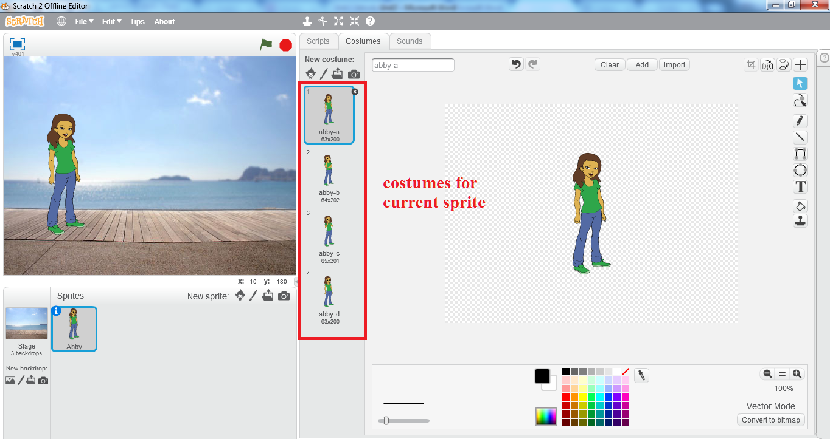

3.3 (d) costumes

While sprites contain costumes, the [Stage](https://en.scratch-wiki.info/wiki/Stage) contains backdrops. They can be used in the same way.

* **Sprite**

Sprites, either user created, uploaded, or found in the [sprites library](https://en.scratch-wiki.info/wiki/Libraries#Sprites_Library), are the [objects](https://en.scratch-wiki.info/wiki/Object-Oriented_Programming) that perform actions in a [project](https://en.scratch-wiki.info/wiki/Project). While the [Stage](https://en.scratch-wiki.info/wiki/Stage) can also be programmed in a project, most projects have at least one sprite as well because only sprites can move.

* + **Creating a sprite**

The bar above the sprite list has four buttons for creating sprites. They are:

* + - The [Giga](https://en.scratch-wiki.info/wiki/Giga) button allows you to choose a sprite from the [library](https://en.scratch-wiki.info/wiki/Libraries#Sprites_Library).
    - The paintbrush button creates a blank sprite with an empty costume.
    - The folder button allows you to upload a sprite from your computer.
    - The camera button allows you to take a picture and uses that image as the sprite.

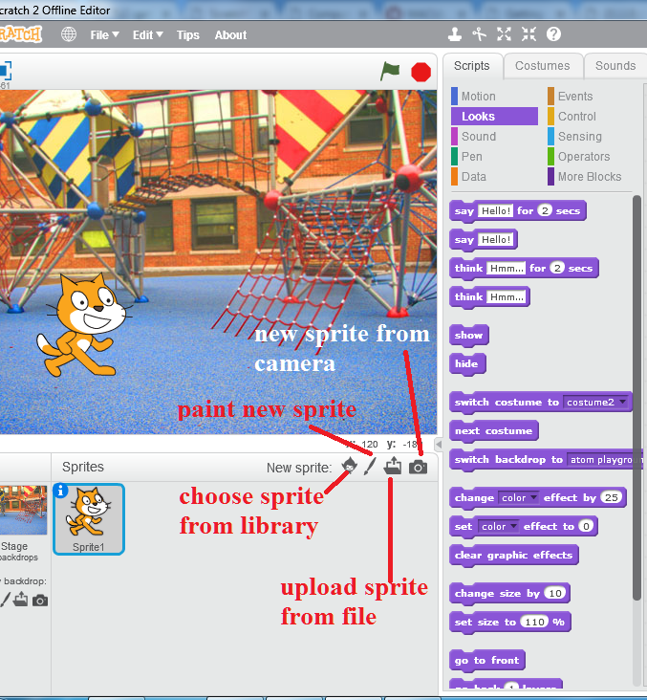**3.1 (e) create new sprite**

When a sprite is created, it will place that sprite at a random location on the Stage, usually around the center, and open the sprite in the tab you're currently viewing.



Try It Yourself!

* Click on *paint new sprite* button
* Scratch paint editor will open up
* Using the ellipse tool on the left side draw an ellipse
* Use the *fill with color* tool to fill it with red color
* The red ball sprite will appear on the stage and

its thumbnail will appear in the sprites list with

the name *Sprite 1*

* + **Scripts tab**

Each sprite in a Scratch project has an area for [scripts](https://en.scratch-wiki.info/wiki/Script), called the [scripts area](https://en.scratch-wiki.info/wiki/Scripts_Area). Users can give instructions to a sprite (such as telling the sprite to move) by snapping [blocks](https://en.scratch-wiki.info/wiki/Blocks) together in the scripts area. Clicking on the blocks in the script area will cause the sprite to react based on the function of the blocks clicked. Clicking on a sprite's thumbnail in the sprite pane will bring up the script area of that sprite.

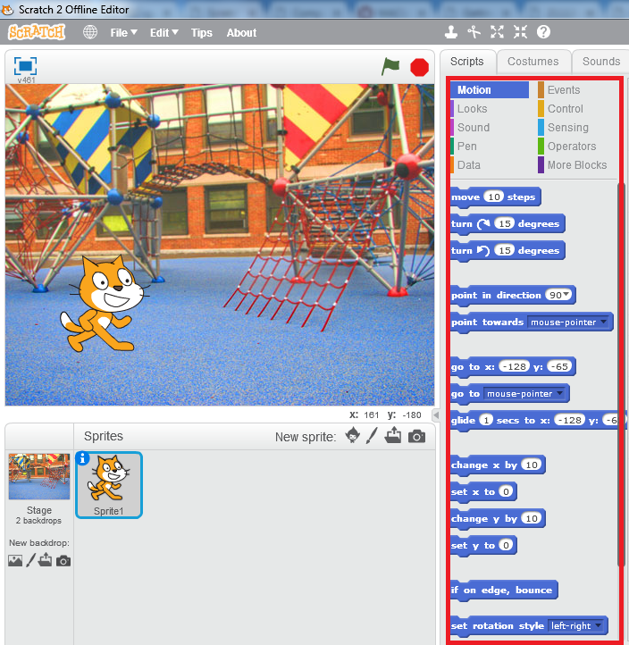

3.1 (f) scripts tab for sprite

* + **Costumes tab**

The look of a sprite can also be changed by using [costumes](https://en.scratch-wiki.info/wiki/Costume). The current costume of a sprite can be changed by clicking on the *costumes* tab and clicking on the desired costume of choice, or by using [Looks](https://en.scratch-wiki.info/wiki/Looks) blocks to select the sprite's costume. New costumes for the sprite can be imported, created, and edited in the Scratch [Paint Editor](https://en.scratch-wiki.info/wiki/Paint_Editor).

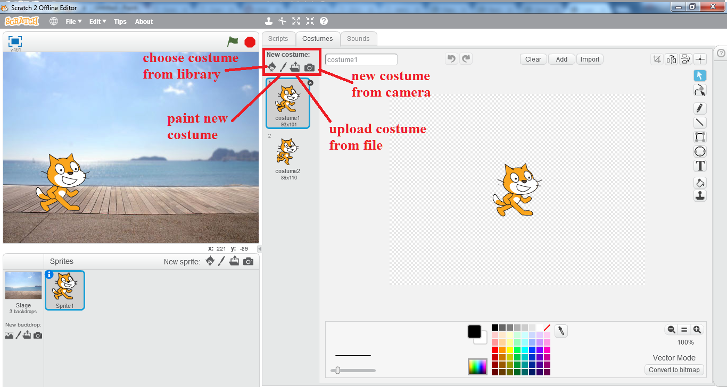

3.1 (g) costumes tab for sprite

* + **Sounds tab**

Some sprites additionally have at least one [sound](https://en.scratch-wiki.info/wiki/Sound). Unlike costumes, sounds are an optional field, so you can have a sprite with no sounds. The sounds tab allows you to add, delete, and [edit](https://en.scratch-wiki.info/wiki/Sound_Editor) sounds. Sounds can be played in the sound editor or with blocks that play a specific sound.



Try It Yourself!

* In the *blocks palette* select *Sound*
* Click and drag J:\PTBB\unit 3\play.png block

to the *scripts area*

* Click on the play sound block in the *scripts area*
* You will be able to listen to the meow sound.

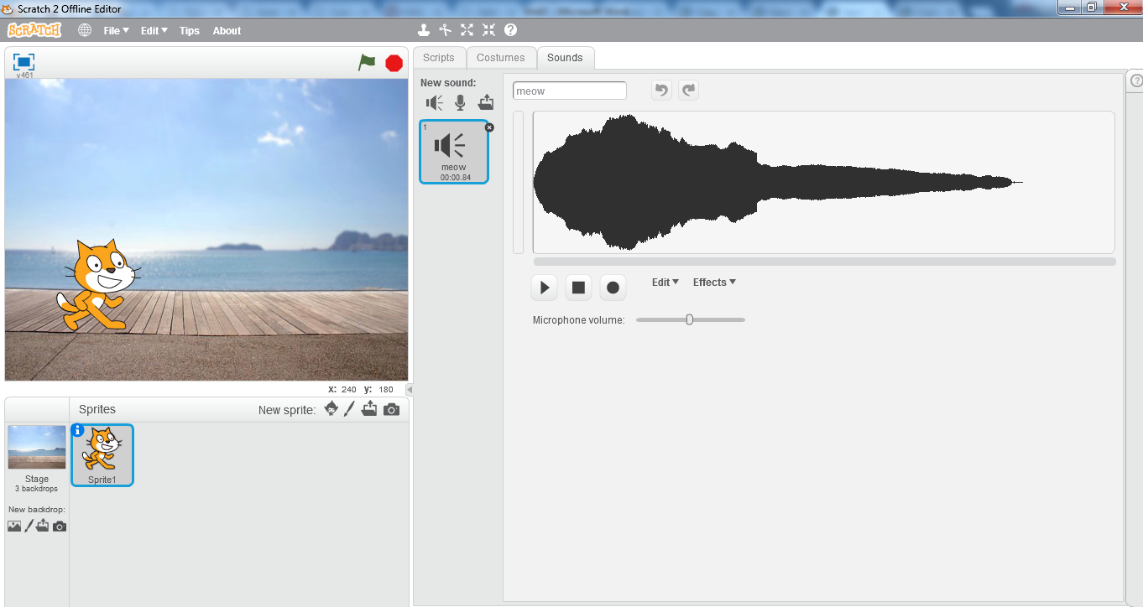

3.1 (h) sounds tab for sprite

* **Stage**

The **Stage** is the term for the background of the [project](https://en.scratch-wiki.info/wiki/Project), but it can have [scripts](https://en.scratch-wiki.info/wiki/Script), [backdrops](https://en.scratch-wiki.info/wiki/Backdrops) (costumes), and [sounds](https://en.scratch-wiki.info/wiki/Sound). It does not have all functionalities as that of a sprite such as motion [blocks](https://en.scratch-wiki.info/wiki/Blocks). No sprites can move behind the Stage; the Stage is always at the back layer.

* + **Scripts tab**

The Stage field has a scripts tab that can be used in the same way as in a sprite, with the following exceptions:

* + - The [motion](https://en.scratch-wiki.info/wiki/Motion_Blocks), say, think, [Show](https://en.scratch-wiki.info/wiki/Show_(block)), [Hide](https://en.scratch-wiki.info/wiki/Hide_(block)), [costume](https://en.scratch-wiki.info/wiki/Costume) blocks cannot be used.
    - The [Switch Backdrop to () and Wait](https://en.scratch-wiki.info/wiki/Switch_Backdrop_to_()_and_Wait_(block)), [Next Backdrop](https://en.scratch-wiki.info/wiki/Next_Backdrop_(block)), and [Backdrop #](https://en.scratch-wiki.info/wiki/Backdrop_Number_(block)) blocks are only for the Stage.

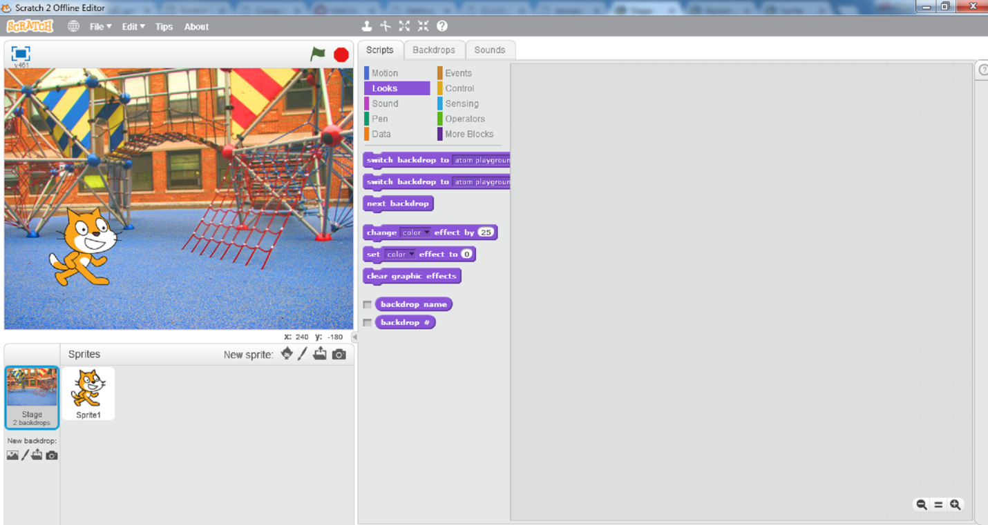

3.1 (i) stage scripts

* + **Backdrops tab**

There is also a **backdrops tab** that can be used to add, delete, and edit backdrops. This field is required, and the last remaining backdrop cannot be deleted. The dimensions are always 480x360. Transparent areas automatically become white in the project.

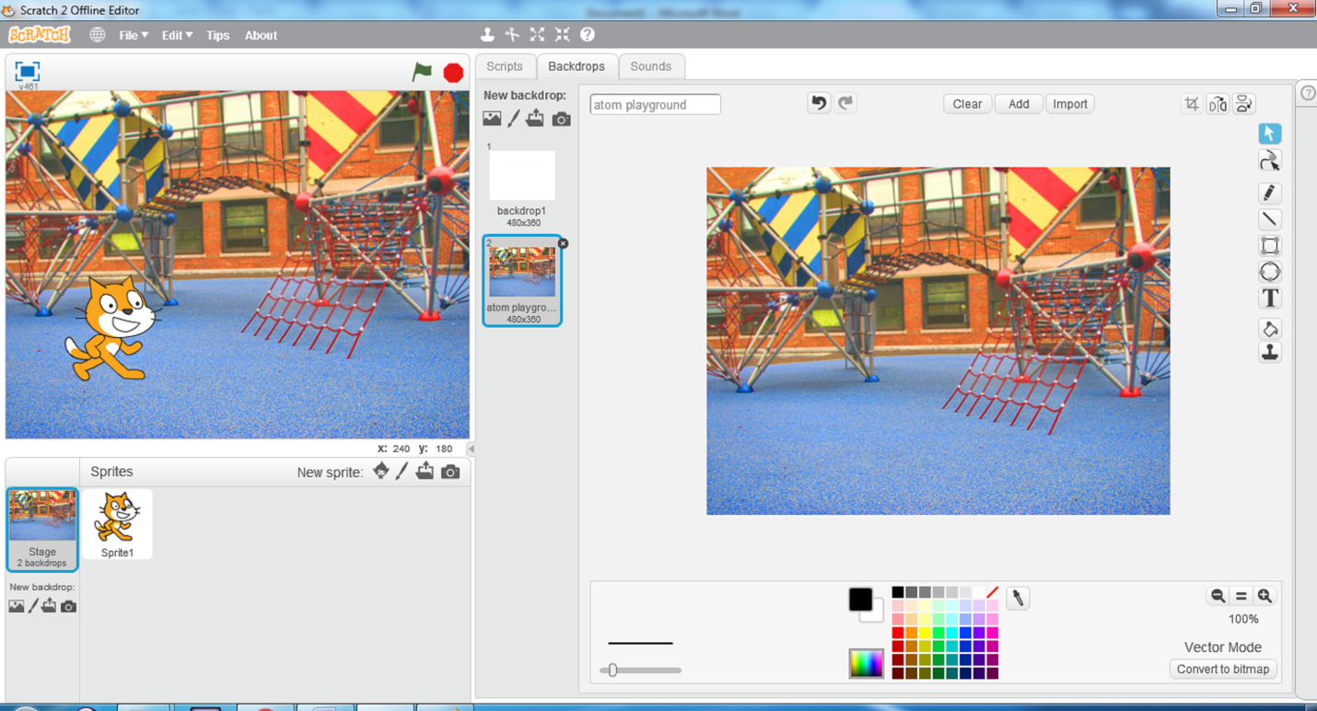

3.1 (j) stage backdrops

* + **Sounds tab**

The optional sounds tab is identical to the sounds tab in sprites.

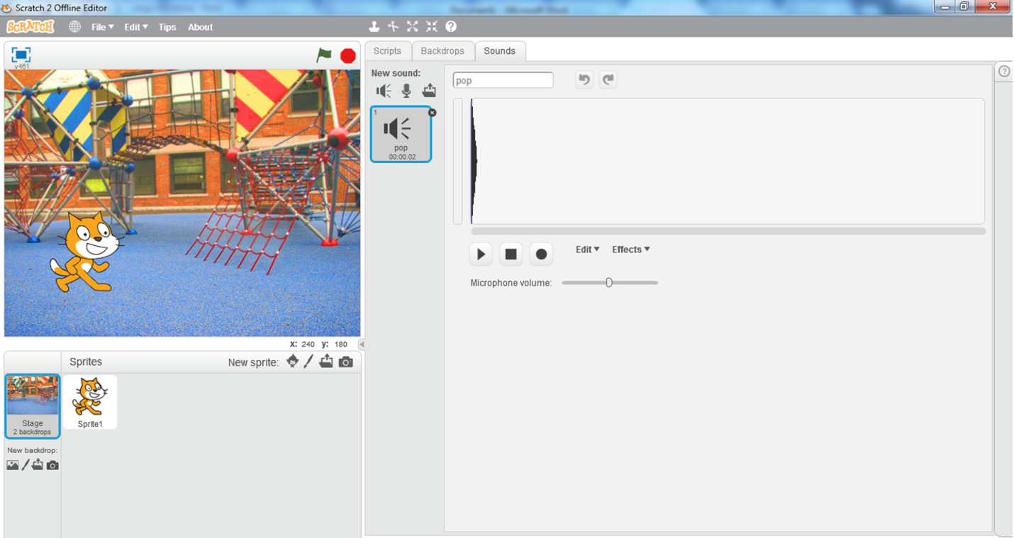**3.1 (k) stage sounds**

* + **Stage sizes**

The stage can be of 3 different sizes:

* + - **Regular**

Normal mode; the Stage is 480x360 pixels.

* + - **Small Stage Layout**

The stage is half the size with a resolution of 240x180 pixels; this is useful for having more room in the scripts area. This option can be accessed through the *Edit* option.

* + - **Full-screen mode**

It fits the stage to your computer’s current resolution.

# 2 Animation

**Selecting a new sprite**

* + Open scratch offline editor
  + By default *cat* sprite is selected
  + Right-click on the cat sprite thumbnail in the sprite list area and click on *delete*

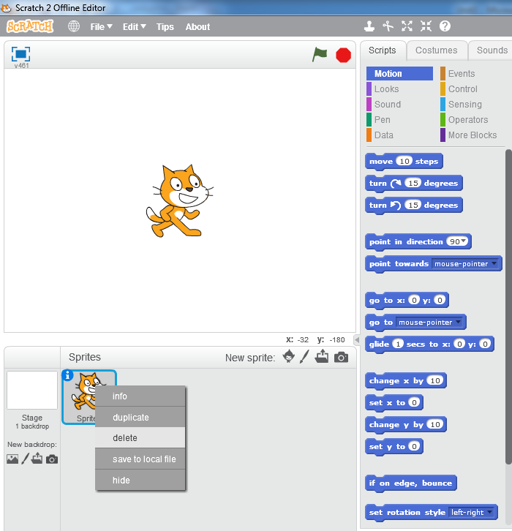

**3.2 (a) deleting the sprite**

* Click on the *Giga* button in the *New sprite* area to select a new sprite from the library
* Sprite library will open up.

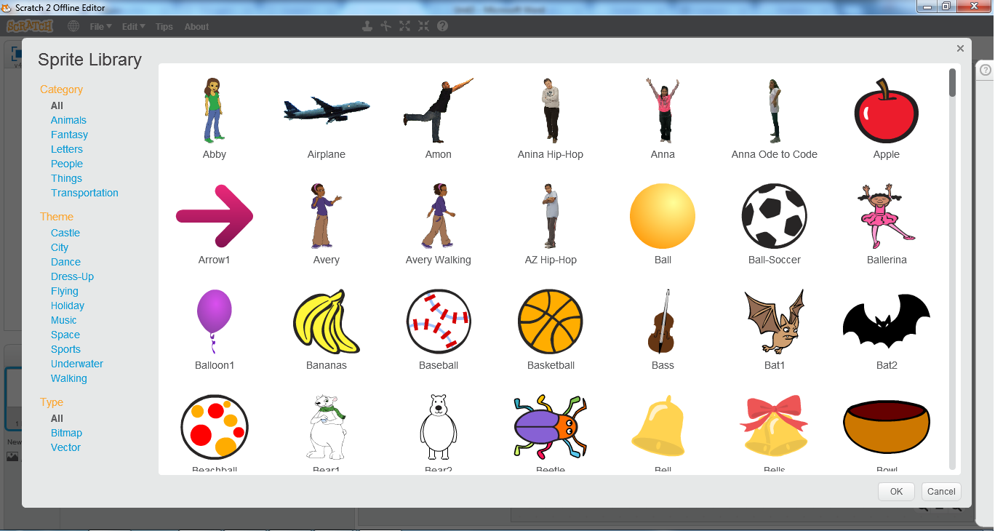

**3.2 (b) sprite library**

* Select the first sprite *Abby* and click ok
* Sprite will be placed on the stage at a random point and its thumbnail will appear in the sprite list.

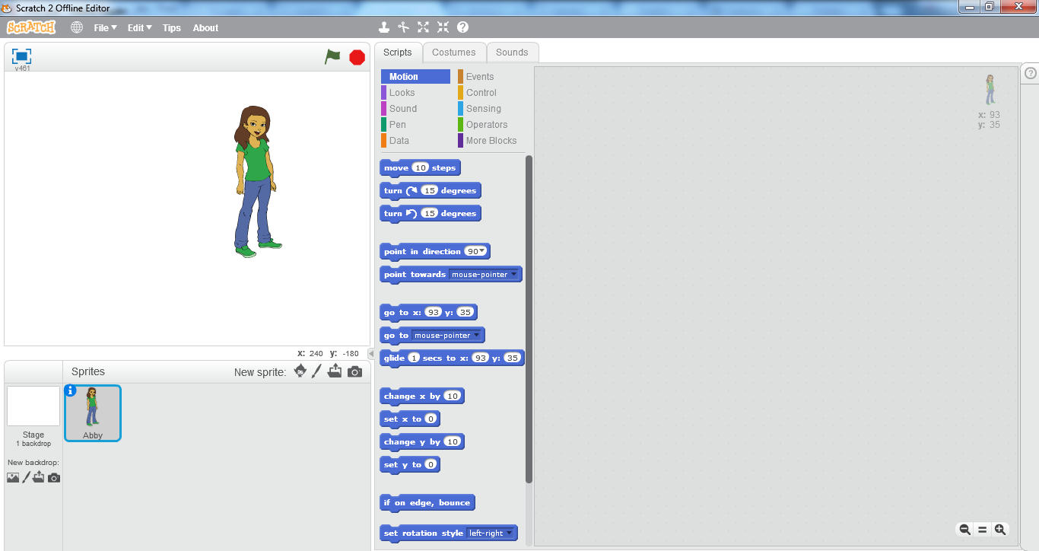

**3.2 (c) Abby sprite**

**Moving the Sprite**

* Drag and place *Abby* on the left most corner of the stage
* From the *Blocks Palette* area drag “*move 10 steps”* to the *scripts area.*

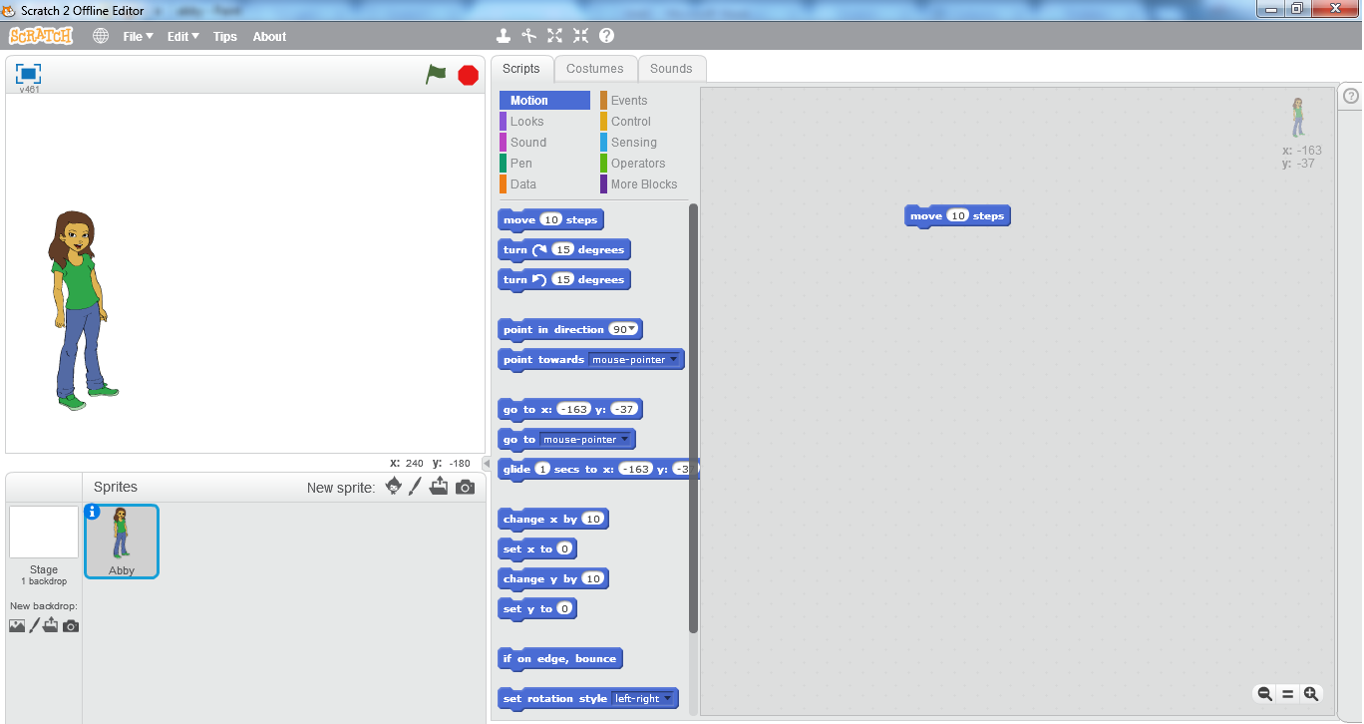

**3.2 (d) moving the sprite**

* Click on the move block in the scripts area
* You can see the sprite *Abby* moving to the right side of the stage
* Keep clicking on the move block until the sprite reaches the right end of the stage.

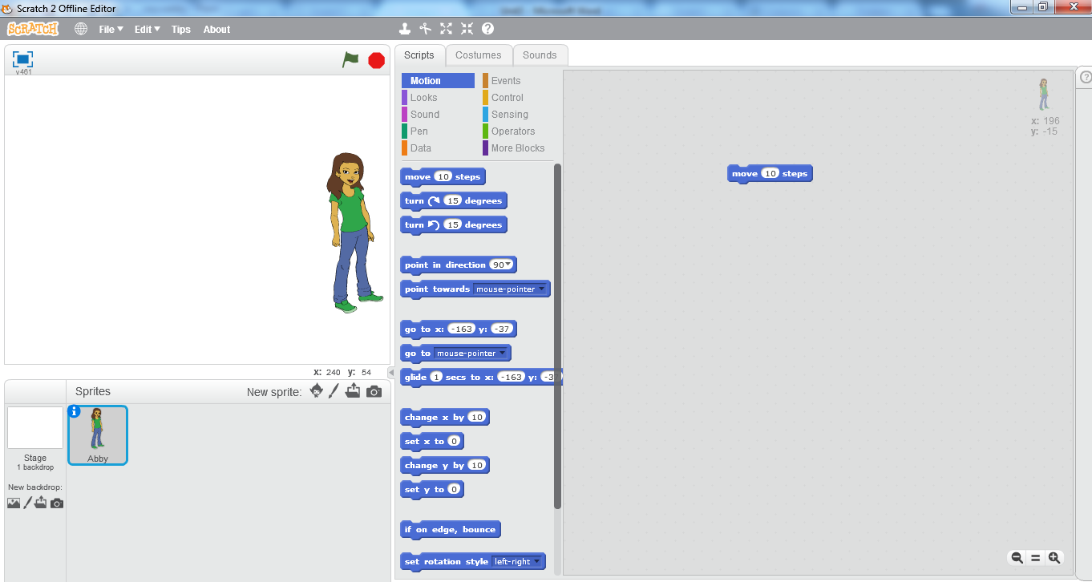

**3.2 (e) moving the sprite**

Try It Yourself!

* You can also change the number of steps your

sprite will move

* Write 50 in place of 10 steps
* Click on the move block and see the difference

in movement of sprite

* Write 100 and click on the move block



# 3 Conversation

* Click and Drag the sprite *Abby* to the left most side of the stage
* Click on the *Giga* button to open sprite library
* Choose another sprite *Avery*

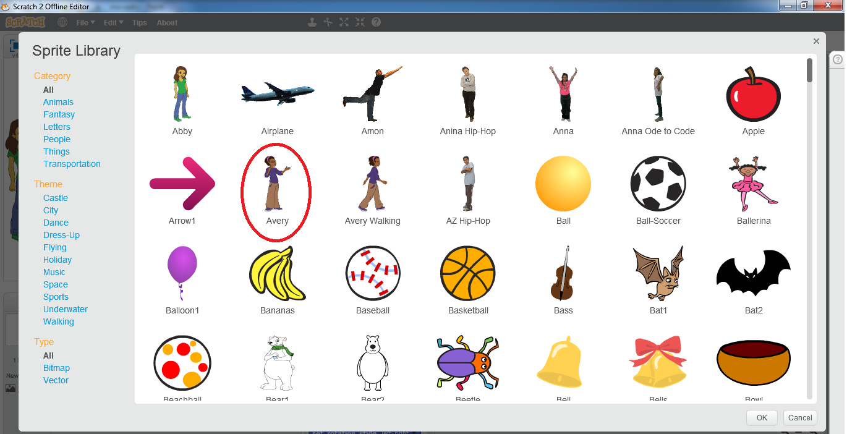

**3.3 (a) sprite library**

* It will be placed randomly on the stage and its thumbnail will appear in the sprites list

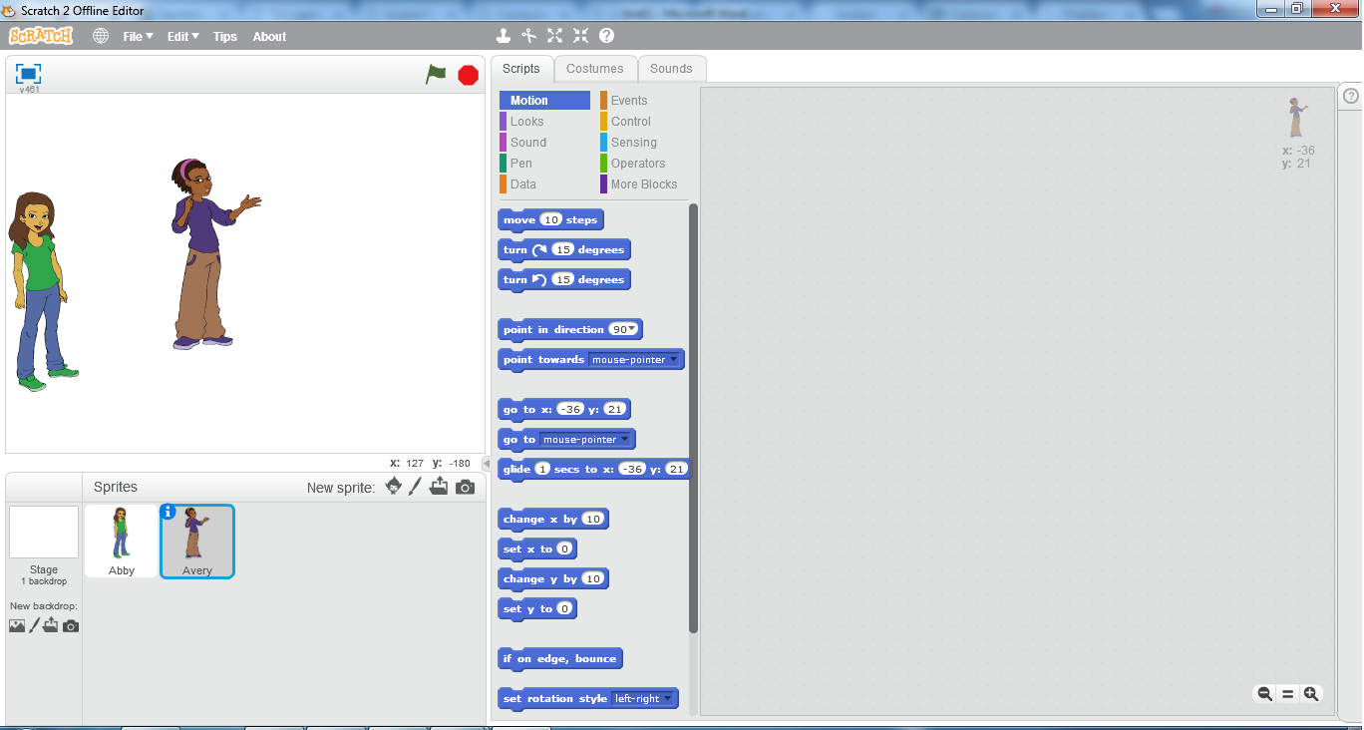

**3.3 (b) creating another sprite**

* Click and drag *Avery* to the right most side of the stage
* Click on the *costumes* tab
* In the scratch paint editor, click on the *Flip left-right* button in the top left corner of the screen

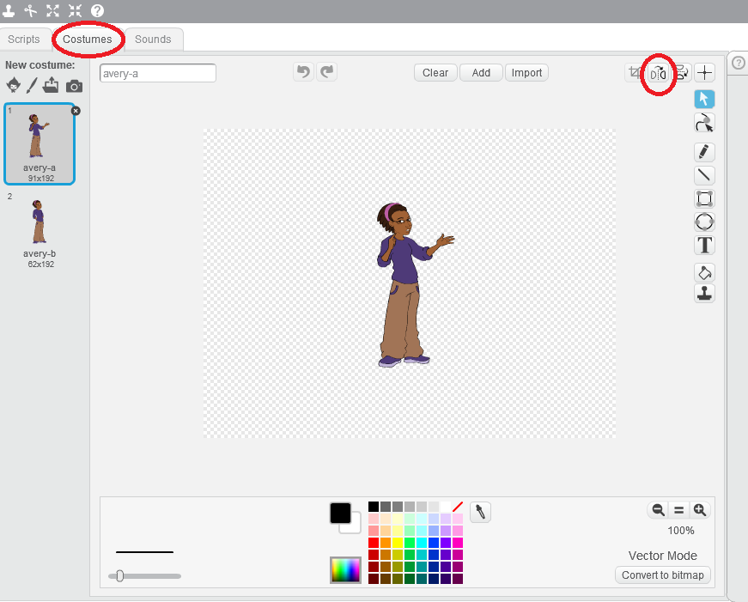

**3.3 (c) Avery costumes**

* By clicking on this button, the sprite *Avery’s* direction will change to the left side instead of right side

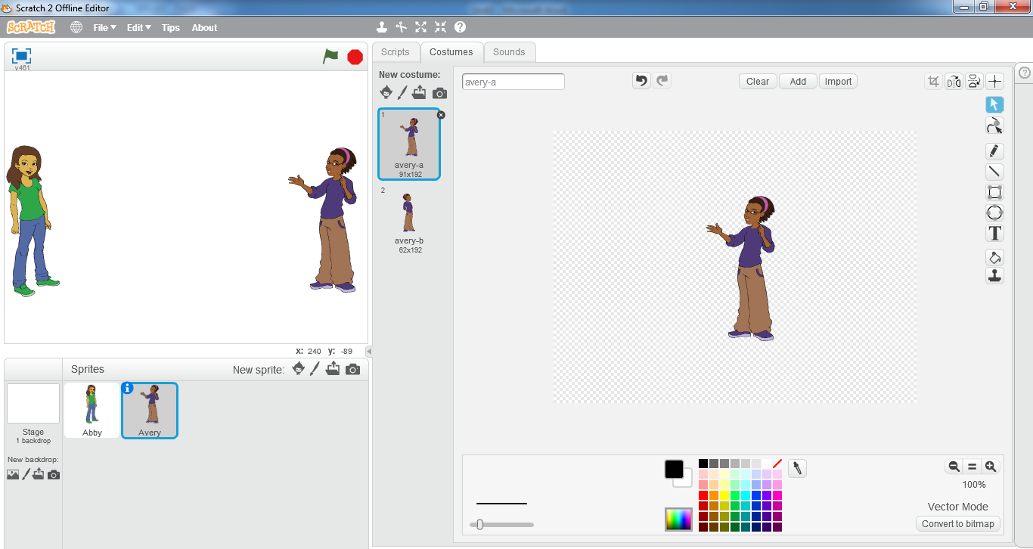

**3.3 (d) flip left-right**

**Using Speech Bubble**

* Click on *Scripts*
* Click on *Events*
* Click and drag the hat block J:\PTBB\unit 3\whenclickd.png to the scripts area
* Click on *Looks*
* Click and drag the block J:\PTBB\unit 3\sayhel.png to the scripts area
* Drag the block J:\PTBB\unit 3\sayhel.png towards the below side of the hat block until you see the below area of hat block highlighted.
* Release the mouse at that point. Both blocks should be merged together like this 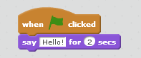
* Now click on the flag button
* You can see the sprite *Avery* saying Hello to the sprite *Abby*

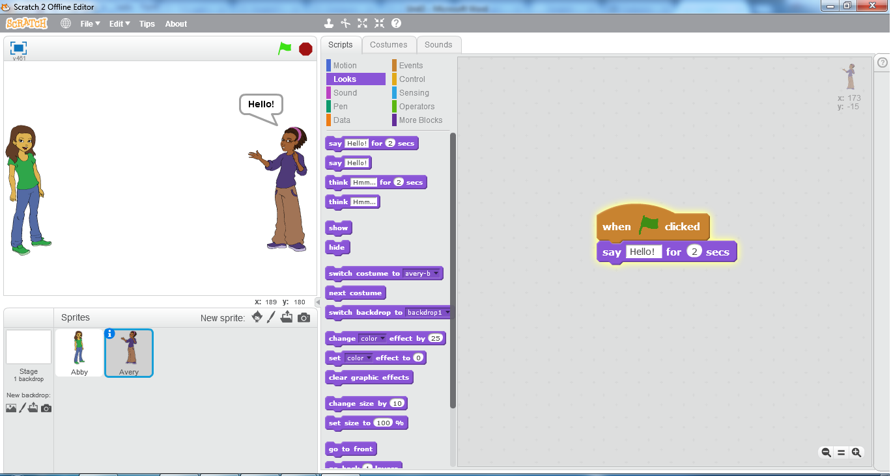

**3.3 (e) sprite Avery saying hello**

Try It Yourself!

* You can also change the message that you want

your sprite to speak

* Click in the area where *Hello* is written in the *say*

block

* Write “*hello my friend*”
* Click on the *say* block
* You can see you sprite speaking the new message
* Write 5 in place of 2 secs and then click on the *say*

block



**Using Thought Bubble**

* Click on J:\PTBB\unit 3\sayhel.png block and drag it back into the *blocks pallete* area.
* Click on J:\PTBB\unit 3\think.png block and drag it into the *scripts area*
* Drag it below the *hat block* until you see the below part of the hat block highlighted and then attach it with the hat block. 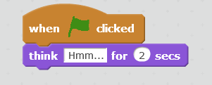
* Now click on the green flag button

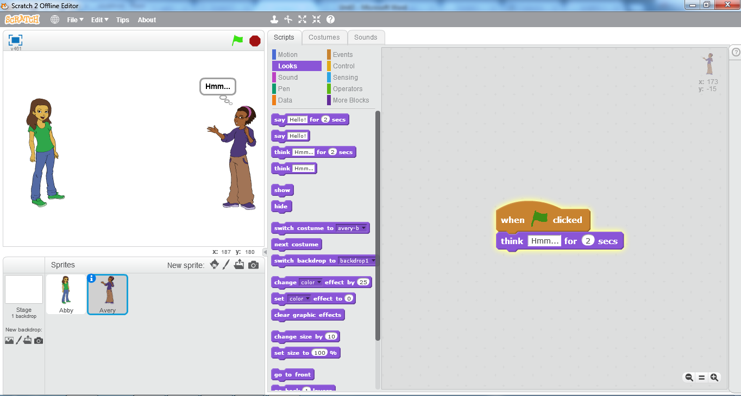

**3.3 (f) sprite Avery thinking**

* You can see the sprite *Avery* thinking *hmm…*

**Using Wait Controls**

* In the *sprites list* area click on the sprite *Abby* thumbnail.
* Click and drag  block to the *scripts area* and attach it with the 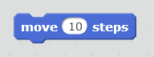 block.

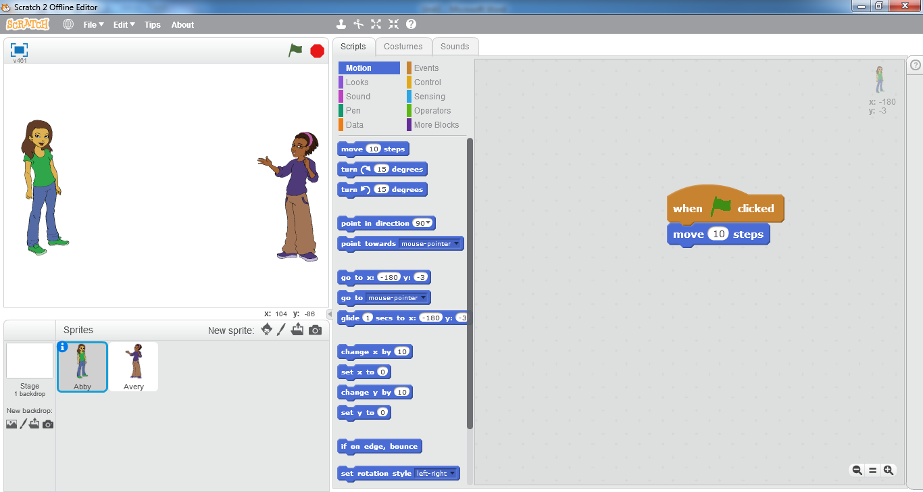

**3.3 (g) sprite Abby script**

* Click on *Looks*
* Click and drag J:\PTBB\unit 3\sayhel.png to the *scripts area* and attach it below the *move* block 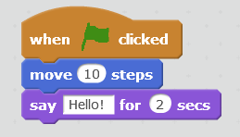
* Click on sprite *Avery* thumbnail in the *sprite list* area
* Click and drag all script blocks from the s*cripts area* except the *hat block*
* Click and drag J:\PTBB\unit 3\sayhel.png block from the *blocks palette* to the *scripts area* and attach it below the *hat* block 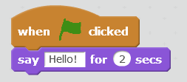
* Click on the green flag button

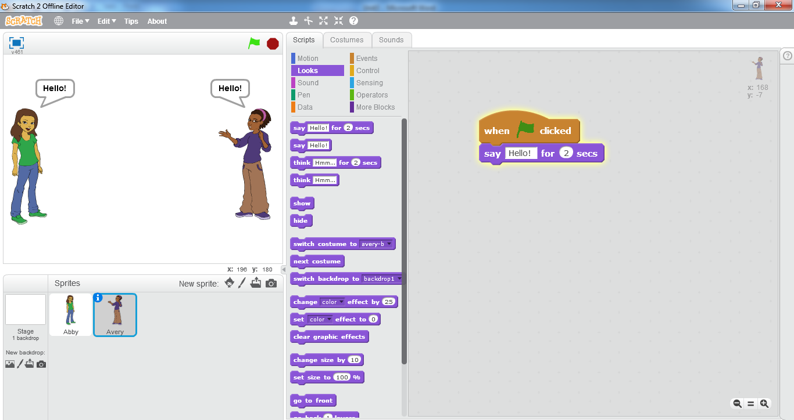

**3.3 (h) Both sprites saying hello**

You can see that scripts of both sprites are being played simultaneously and both are saying *hello* at the same time.

* Now in the *blocks* *palette* of sprite *Avery,* Click on *Control*
* Click and drag  from the *blocks palette* to the *scripts area* and Edit the wait block by writing 2 in place of 1



* Attach it between the hat block and the *hello* block.

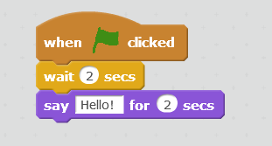

* Click on the green flag button. You can see the scripts of both sprites being played on the stage

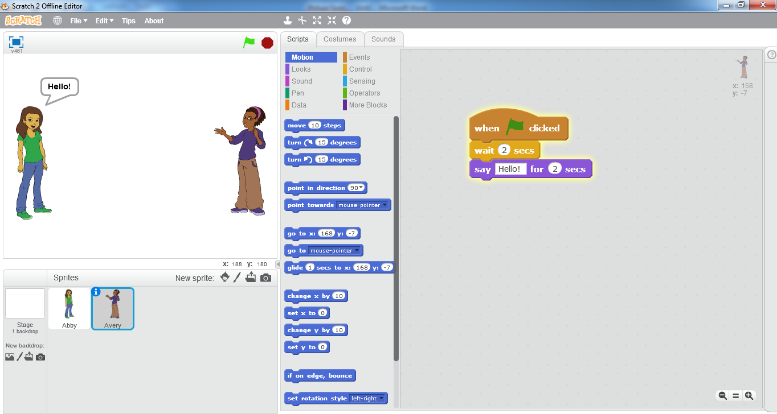

**3.3 (i) Sprite Abby saying hello**

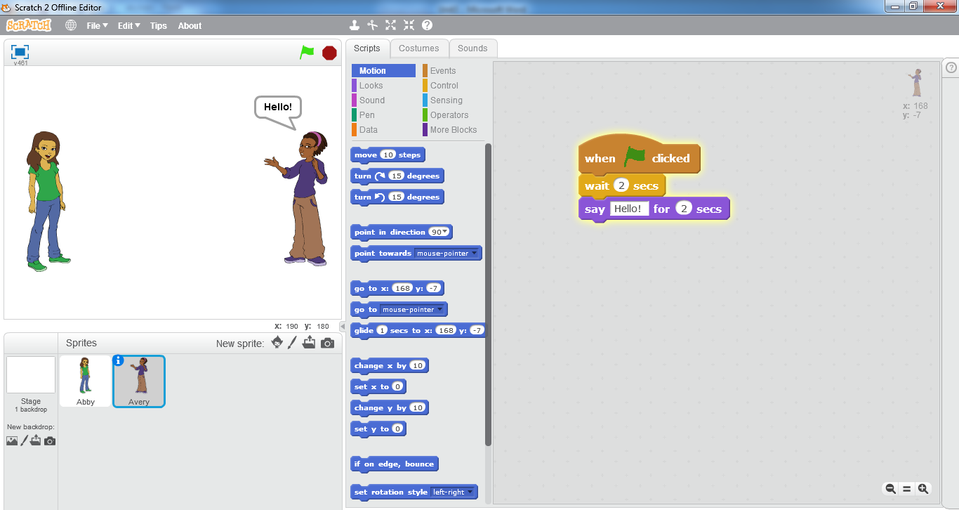

**3.3 (j) sprite Avery saying hello**

You can see that first the sprite *Abby* will move towards the sprite *Avery* and then it will say *hello.* After that the sprite *Avery* will also say *hello* in return. The difference in the timings of saying *hello* from both sprites is caused due to the use of *wait* block.